Form level validation
Form level validation is nothing validating multiple fields.
For performing form level validation “clean” method of super class (Form) must be override.

Syntax:
Class form-class-name(forms.Form):
Field-name=type
Field-name=type
Field-name=type

def clean(self): # overriding method
super().clean()
logic for validating of multiple fields

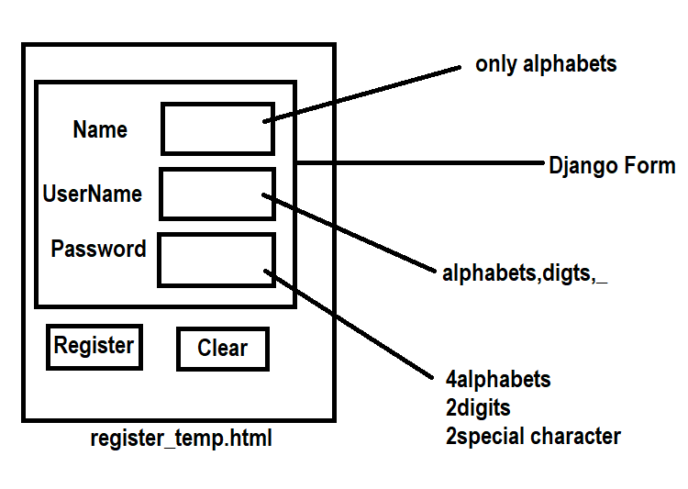

PS D:\Backup\Django9amMar> django-admin startproject project14
PS D:\Backup\Django9amMar> cd project14
PS D:\Backup\Django9amMar\project14> python manage.py startapp app
PS D:\Backup\Django9amMar\project14>

forms.py
from django import forms
import re
class RegisterForm(forms.Form):
name=forms.CharField(max_length=20)
uname=forms.CharField(max_length=15,label="UserName")
password=forms.CharField(widget=forms.PasswordInput())

def clean(self):
data=super().clean()
if not data['name'].isalpha():
raise forms.ValidationError("Name should contain only alphabets")

m=re.fullmatch('\w+',data['uname'])
if m==None:
raise forms.ValidationError("Username should contain alphabets,digits and _")

pwd=data['password']
c1,c2,c3=0,0,0
for ch in pwd:
if ch.isalpha():
c1=c1+1
elif ch.isdigit():
c2=c2+1
else:
c3=c3+1
if c1<4 or c2<2 or c3<2:
raise forms.ValidationError("Password should contains 4 alphabets 2 digits 2 special character ")

return data

views.py
from django.shortcuts import render
from app.forms import RegisterForm
from django.http import HttpResponse
# Create your views here.

def register(request):
if request.method=="GET":
form=RegisterForm()
response=render(request,"register_temp.html",context={'form':form})
return response
else:
form=RegisterForm(request.POST)
if form.is_valid():
response=HttpResponse("<h2>Data is Valid</h2>")
return response
response=render(request,"register_temp.html",context={'form':form})
return response

register_temp.html
<!DOCTYPE html>
<html lang="en">
<head>
<meta charset="UTF-8">
<meta name="viewport" content="width=device-width, initial-scale=1.0">
<title>Document</title>
</head>
<body>
<table border="2" width="100%">
<form method="post">
{%csrf_token%}
{{form.as_table}}
<tr>
<td><input type="submit" value="register"></td>
<td><input type="reset" value="clear"></td>
</tr>
</form>
</table>

</body>
</html>

Urls.py
from django.contrib import admin
from django.urls import path
from app.views import register
urlpatterns = [
path('admin/', admin.site.urls),
path('register/',register)
]

Settings.py
TEMPLATES = [
{
'BACKEND': 'django.template.backends.django.DjangoTemplates',
'DIRS': [BASE_DIR/"templates"],
'APP_DIRS': True,
INSTALLED_APPS = [
'django.contrib.admin',
'django.contrib.auth',
'django.contrib.contenttypes',
'django.contrib.sessions',
'django.contrib.messages',
'django.contrib.staticfiles',
'app'
]

Working built-in validators
In Django, a validator is a callable (a function or class with a __call__ method) that takes a value and raises a ValidationError if it doesn't meet specific criteria. They are primarily used to ensure data integrity across model fields and forms.

There are 2 types of validators
- Builtin validatiors
- Custom validators (OR) user defined validators

1. Built-in Validators
Django provides a comprehensive set of pre-built validators in the django.core.validators module.

- EmailValidator: Ensures a string is a properly formatted email address.
- RegexValidator: Checks if a value matches a specific regular expression pattern.
- MinValueValidator / MaxValueValidator: Validates that a numeric value falls within a specific range.
- MinLengthValidator / MaxLengthValidator: Enforces minimum or maximum character lengths for strings.
- URLValidator: Confirms that a string is a valid URL

PS C:\Users\Satish Gupta> cd D:\Backup\Django9amMar
PS D:\Backup\Django9amMar> django-admin startproject project15
PS D:\Backup\Django9amMar> cd project15
PS D:\Backup\Django9amMar\project15> python manage.py startapp app
PS D:\Backup\Django9amMar\project15>

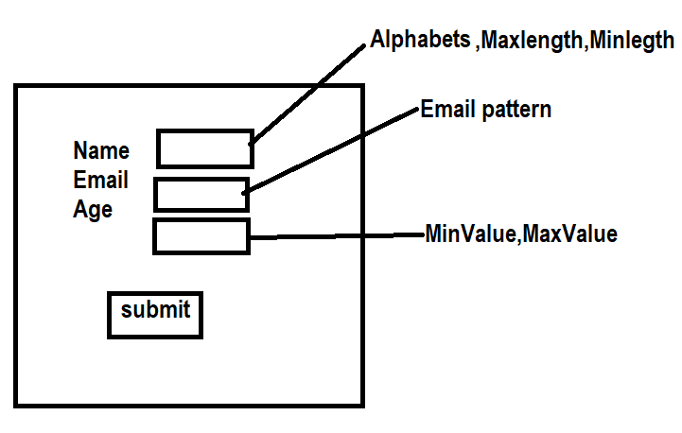

Forms.py
from django import forms
from django.core.validators import MaxLengthValidator,MinLengthValidator
from django.core.validators import RegexValidator
from django.core.validators import EmailValidator
from django.core.validators import MinValueValidator,MaxValueValidator
class PersonForm(forms.Form):
name=forms.CharField(validators=[RegexValidator(regex=r'[A-Za-z]{3,15}',message='name must contain only alphabet range from 3 to 15')])
email=forms.CharField(validators=[EmailValidator()])
age=forms.IntegerField(validators=[MinValueValidator(18),MaxValueValidator(100)])

person_temp.html
<!DOCTYPE html>
<html lang="en">
<head>
<meta charset="UTF-8">
<meta name="viewport" content="width=device-width, initial-scale=1.0">
<title>Document</title>
</head>
<body>
<table border="2" width="100%">
<form method="post">
{%csrf_token%}
{{form.as_table}}
<tr>
<td><input type="submit" value="submit"></td>
<td><input type="reset" value="reset"></td>
</tr>
</form>
</table>
</body>
</html>

Views.py
from django.shortcuts import render
from app.forms import PersonForm
from django.http import HttpResponse
# Create your views here.

def person_view(request):
if request.method=="GET":
form=PersonForm()
response=render(request,"person_temp.html",context={'form':form})
return response
else:
form=PersonForm(request.POST)
if form.is_valid():
response=HttpResponse("<h2>Input data is valid</h2>")
return response
response=render(request,"person_temp.html",context={'form':form})
return response

urls.py
from django.contrib import admin
from django.urls import path
from app.views import person_view
urlpatterns = [
path('admin/', admin.site.urls),
path('personview/',person_view)
]

Settings.py
INSTALLED_APPS = [
'django.contrib.admin',
'django.contrib.auth',
'django.contrib.contenttypes',
'django.contrib.sessions',
'django.contrib.messages',
'django.contrib.staticfiles',
'app'
]
TEMPLATES = [
{
'BACKEND': 'django.template.backends.django.DjangoTemplates',
'DIRS': [BASE_DIR/"templates"],
'APP_DIRS': True,

Custom validators or user defined validators

Custom validator is a function or class, which is used to perform validations (input data is correct or not). Validators are reusable, once validator is developed it is used with one or more than one field (OR) multiple applications.

Basic steps
- Create validator
- Apply validator

